
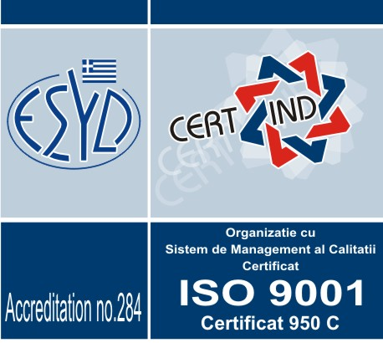
Roman ,str Stefan cel Mare nr 268
Jud Neamt ,Romania
Tel/fax 0233743701
Web page:www.marsatsa.ro
Email :office@marsatsa.ro
comercial.marsat@gmail.com
DISTRIBUITOR AUTORIZAT
CAMPANIA 2014
OFERTA : SAMANTA PORUMB
FURNIZOR | HIBRID | GRUPA FAO | GRUPA MATURITATE  TIP BOB | AMBALAJ/  TRATAMENT SAMANTA | PRET  RON fara TVA
 | P 9025 | 300 | Timpuriu | 80000/Maxim XL | 675
 | P8576 | 290 | Semi timpuriu/dentat | 80000/Maxim XL | 660
 | PR 39 R 20 | 280 | Semi timpuriu/sticlos | 80000/Maxim XL | 550
 | P9721 | 380 | Semi-Timpuriu | 80000/Maxim XL | 710
 | P 8745 | 295 | Timpuriu /dentat | 80000/Maxim XL | 660
 | P9528 | 350 | Semitimpuriu /dentat | 80000/Maxim XL | 710
 | P 9578 | 320 | Semitimpuriu /dentat | 80000/Maxim XL | 710
 | AMADEO | 250 | Timpuriu | 50000/fungicid | 370
 | SEVERO | 270 | Timpuriu/indurat | 50000/fungicid | 400
 | GAVOTT | 280 | Timpuriu/semiindurat | 50000/fungicid | 370
 | KRABAS | 330 | Timpuriu | 50000/fungicid | 420
 | KAMELIAS | 340 | Timpuriu | 50000/fungicid | 420
 | KINEMAS | 350 | Timpuriu | 50000/fungicid | 420
 | KORNELIUS | 400 | Tardiv | 50000/fungicid | 420
 | KWS 2376 | 350 | Timpuriu | 50000/fungicid | 420
 | MIKADO | 550 | Tardiv/ siloz | 50000/fungicid | 400
 | AMELIOR | 240 | Extratimpuriu/siclos/ | 50000/Thirame | 340
 | MAS 26 K | 250 | Extratimpuriu /sticlos | 50000/Thirame | 370
 | MAS 29 H | 270 | Semitimpuriu /sticlos | 50000/Thirame | 380
 | MAS 37 V | 370 | Semitimpuriu/dentat | 50000/Thirame | 370
 | MAS 38 D | 260 | Extratimpuriu /sticlos | 50000/Thirame | 350
 | MAS 33A | 350 | Semitimpuriu /semisticlos | 50000/Thirame | 400
 | MAS 36 A | 360 | Semitimpuriu /dentat | 50000/Thirame | 380
 | CLARITI CS | 320 | Timpuriu/dentat | 50000/Fungicid | 340
 | CORTI CS | 340 | Timpuriu /dentat | 50000/fungicid | 380
 | VERRI CS | 300 | Timpuriu /semisticlos | 50000/Fungicid | 340
 | HERKULI CS | 310 | Timpuriu/semisticlos | 50000/Fungicid | 410
 | CRAZI CS | 310 | Timpuriu/semisticlos | 50000/Fungicid | 380
 | NK OLYMPIC | 230 | Timpuriu /dentat | 50000/Maxim XL | 400
 | AROBASE | 250 | Timpuriu/Sticlos | 50000/Cruiser | 350
 | NK SYMBA | 290 | Timpuriu/ | 50000/Maxim XL | 400
 | NK KANSAS | 300 | Timpuriu | 50000/Maxim XL | 400
 | CERA 270 | 270 | Timpuriu | 50000/fungicid | 450
 | CERA 290 | 290 | Timpuriu/dentat | 50000/fungicid | 420
 | DKC 4590 | 350 | Timpuriu | 80000/fungicid | 750
 | DKC 4014 | 300 | Timpuriu | 80000/fungicid | 750
 | DKC 4025 | 320 | Timpuriu | 80000/fungicid | 750
 | DKC 3811 | 280 | Extra timpuriu | 80000/fungicid | 750
 | DKC 4490 | 360 | Semi timpuriu | 80000/fungicid | 745
 | DKC 3511 | 310 | Timpuriu | 80000/fungicid | 650
 | DKC 4685 | 340 | Timpuriu | 80000/fungicid | 650

